Name:_________________________

**Using the Buttons and Servos - MakeCode**

**What you need:**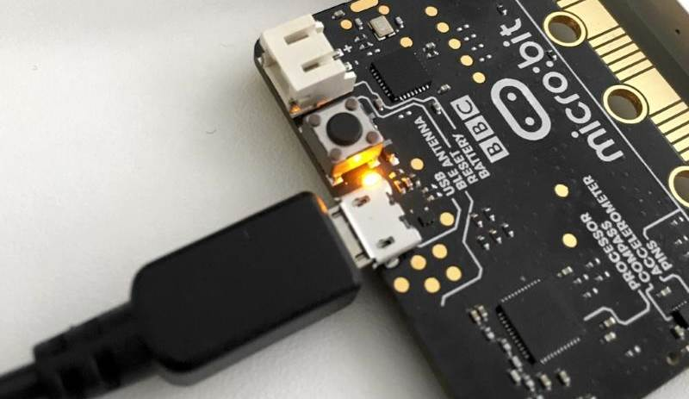

1. A computer with a USB port
2. V2.0 micro:bit
3. USB cable
4. 3 different colored alligator clips
5. SG90 Servo

**Setup:**

1. Plug in your micro:bit with the USB cable. The small USB mircoB end goes to the micro:bit and the regular USB end goes to the computer.
2. Using the provided alligator clips, connect one clip to the pin labeled ‘**0’** on the micro:bit, and the other end to the orange wire on the servo.
3. Take another alligator clip and attach it to the pin on the micro:bit labeled ‘**3V’**, and the other end into the red wire on the servo.
4. Take the last alligator clip and attach it to the pin on the micro:bit labeled ‘**GND’,** and the other end into the **brown** wire on the servo.
5. In a browser, go to <https://makecode.microbit.org/>. This is where you will program your micro:bit.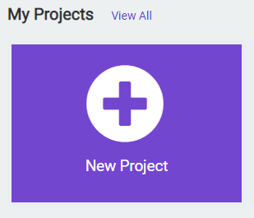
6. Click on ‘New Project’
7. You can name your project whatever you want, but you should name it based on the title of the lab. In this case, ‘Buttons and Servos’

**Instructions:**

1. Inside the **on start** code block, we need to set the **period** of the analog output. The period of an analog signal is the time taken to complete a full cycle. In this case, a full cycle for the servos we are using is 20ms (milliseconds). To do this, click the **Advanced** tab from the code menu and select **analog set period** from the **Pins** tab. The default value also happens to be 20ms by default! Drag this code block to the on start code section.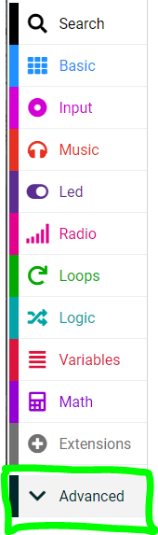

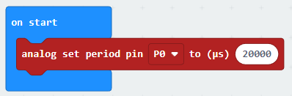

1. Inside the **forever** code block, we will use the an **if** block from the **Logic** tab. This code block will execute whatever code is inside it when the statement we give it becomes true.

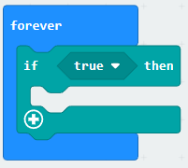

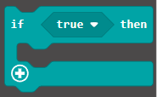

1. Inside the **if** code block, we need to change the condition of when the if statement becomes true. We will change it to when the micro:bit detects when button A is pressed. Drag the **button pressed** logic block from the **Input** tab, inside of the **if** code block where it currently says **true.**

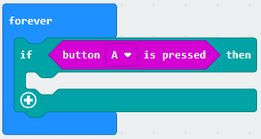



1. To have the micro:bit turn the servo back and forth, we need to use the **servo write pin** code block from the **Pins** tab we looked at earlier**.** If you don’t see the pin tab, it’s under the **Advanced** section of the code menu. To do this, we provide two different signals to the servo. This is called **Pulse Width Modulation** or **PWM.** Drag them into the **if** code block we created previously. Change the time value of the first one to 20 and the second to 100.

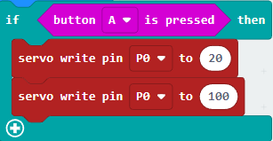



1. If we were to use this code as is, the servo would jiggle a little when we pressed the button, but wouldn’t move like it’s supposed to. We need to create a window of time so that the servo has enough time to complete each turn. To do this, we will use the **wait** code block found on the **Control** tab. If you don’t see the control tab, it’s under the **Advanced** section of the code menu. Drag two of these blocks into your code; one under the first **servo write pin** and one under the second. Change the time value in both blocks to 500000. This will give the servo ½ second to make each turn.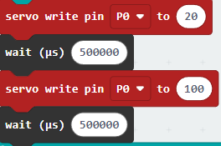



1. Click the **Download** button on the bottom on the bottom left hand side of the screen. This will upload your program to the micro:bit. When you press button **A**, does the servo move back and forth?

**You Try It!**

Can you change how fast the servo moves back and forth?